Homework Grid Spring Term 1 Geography – Countries and Capital Cities Year 4
This half term, we are looking at countries and capital cities. All the activities are based on this. Can you choose 5 activities to do for this half term You may spread these out over the half term, complete them all at once or bring them all in by the due date- the choice is yours! Homework to be in for Wednesday 23rd October.
Learn a language  Choose a country and learn a few words or phrases of their language. (not French) Make sure you know the capital city of the country. | Happy Holidays  Which capital city would you like visit?  Find out more about what you could there and make a poster to encourage them to visit. Include pictures or posters. Make sure you know the capital city. | Tour Guide  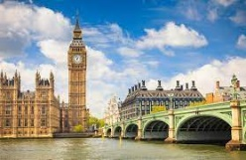  Imagine you are a tour guide. Can you write a leaflet to advertise what attractions you can see in London. Make sure you include pictures and explain what each thing is.  .
Flags of the World  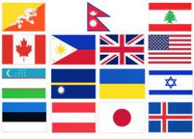  Choose aa couple of countries to draw, paint or make the flag of your choice. Make sure you know the country and capital city. | The Eiffel Tower  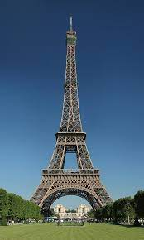  Find out more facts about the  Eiffel Tower and where it is.  Sketch and shade it carefully. .  Which country and capital  city is it in? | Food, Glorious Food    Find out about what foods they eat in Italy. Find a simple recipe and have a go making and tasting it. Make sure you know the capital city.
A Long, Long time Ago  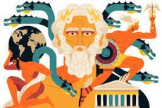  Greece is famous for its Greek Myths. Can you read one of them and retell it in your own words. Remember to make sure you  know the capital of Greece. | National Anthems  Can you listen to the American national anthem? Can you sing some of it and find out about it? Make sure you know what the capital city of the USA is | How many people  Choose a capital city and find facts about it. Write a quiz for the class to Answer about it.

