****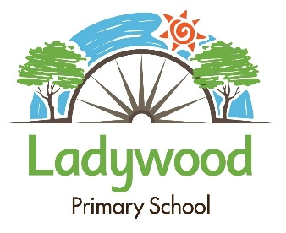

Uniform

Swap Shop

**Let’s re-use our school uniform and save some money!**

**Come along to our uniform swap shop and swap your old uniform (in good wearable condition) for new pre-loved uniform ready for the new school year.**

