**OTHER IMPORTANT INFORMATION**

PE

Year 4 will be swimming on a Monday up to February. Children also need to bring PE kits every Wednesday. It is white t-shirt and black shorts or tracksuit bottoms and trainers for outside. Please make sure hair is tied back and no jewellery is worn, even studs for swimming.

READING RECORDS

Please could you remind your child to bring their reading record in **every** day even if they have not read at home. All children are expected to read at home at least 3 times per week and to record in their reading diaries, even if they read to themselves.

HOMEWORK

Children will be given weekly spellings to practice at home and on Edshed which will be tested each Friday. Children are expected to practice the timetables regularly and TT Rockstars is a super way to do this. They will be told the timestable they should focus on for the week. Children need to know timetables in and out of order and recall at speed, ready for the multiplication test at the end of year 4. They will get topic homework every half term.

**Year 4**

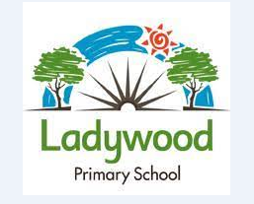

[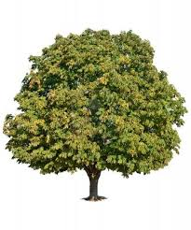](http://www.google.co.uk/url?sa=i&rct=j&q=chestnut+tree&source=images&cd=&cad=rja&uact=8&docid=69HvGeKbLv3JrM&tbnid=s7qLnyMv0UXLTM:&ved=0CAcQjRw&url=http://www.rottenchestnuts.com/&ei=O8QWVOPnLIblaM29gZgO&bvm=bv.75097201,d.d2s&psig=AFQjCNGTHSqqaj3tpl8SQLvt_s8VvOsSQQ&ust=14108645374639)

**Class Teacher**:

**Mr Bowering**

**Assistant Teacher:** **Miss Ducker**

**Class teacher**:

**Miss Horner**

**Teaching Assistants:**

**Mrs Dean Mrs Guy**

In **History,** we will be looking at the Victorian era. We will learn about Queen Victoria, the Industrial revolution and how travel was made easier with steam trains and boats. We will find out about new inventions, the Commonwealth and how schools changed with the education act.

In **Science** we will be looking at changes of state. We will be grouping materials into solids, liquids and gases and finding out how they change. We will be finding out about where we see evaporation and condensation in our daily life, as well as learning about the water cycle.

In **Literacy**, we will use a book based approach using texts to support our writing. We will be writing explanations of the life cycle of a plant. We will be practicing our story writing by writing legends, mystery stories and sequels.

In **Music,** our theme is Mamma Mia. We will learn to sing it and listen to other Abba songs.

In **Computing**, we will be studying computer networks and systems as well as using the internet safely and correctly. We will also look at audio editing.

In **D&T,** we will be designing and making a book sleeve. We will be developing our sewing skills and personalising by decorating it.

In **RE,** we will be looking at significant events in all of the different religions.

In **Maths** we will be concentrating on place value, addition and subtraction. We will be practicing our 2,3,4,5,8 and 10 times tables.

In **Art**, we will be looking at the artist William Morris. We will be developing our sketching skills focusing on shading as well as printing with at least 3 different colours.

In **Geography,** we will be locating Europe on a world map and naming at least 8 capital cities within Europe. We will also be locating capital cities across the world.

In **French,** we will be studying welcome to school including numbers to 20, days of the week and months of the year. We will be learning the names of places in school and different classroom objects.