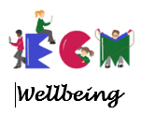

Wellbeing Newsletter
Edition 2: Winter 2024



Welcome to the winter edition of our wellbeing newsletter! In this edition, we will be sharing ideas on how to look after your wellbeing and manage the pressures of the winter months. We will also be sharing some information about the work we do in school to support your child’s wellbeing. We wish you all a wonderful Christmas and New Year!
Page 1

Winter can impact our mental health, especially for young children adjusting to darker days and less time outdoors. Seasonal changes can sometimes lead to lower energy levels, mood dips, and disrupted sleep patterns. It’s important to recognize these changes, as children often look to us for cues on how to handle seasonal adjustments. Here are some easy ways to promote positive wellbeing this season;

- The importance of looking after our wellbeing in winter
 | Establish routines: Consistent routines help children feel secure and regulate their body’s natural rhythms, particularly during the darker winter months. Here are some ways to establish routines:  Set a Regular Bedtime and Wake-Up Time: The body thrives on consistency. Sticking to the same sleep and wake-up times, even on weekends, can improve mood, focus, and energy levels. For younger children, try to make the evening winding down routine enjoyable with a story, bath, or some quiet music.  Use Morning Light to Signal Wake-Up Time: With darker mornings, it can be challenging to wake up. Open the curtains, use a gentle light alarm, or turn on warm, low lighting to help your child wake up gradually. Exposure to natural light as soon as possible helps boost alertness and sets up a healthy sleep-wake cycle.  Create a Wind-Down Routine for Bedtime: Reducing screen time at least an hour before bed can make a big difference in sleep quality. Instead, try reading, quiet drawing, or listening to calming music. Dim the lights in the hour before bed to signal to their body that it’s time to wind down.
Create cosy spaces: A warm, inviting environment can offer a welcome retreat from dark, chilly days and can become a place for relaxation, creativity, and emotional security. Here’s how to build these spaces at home
Set Up a Reading Nook or Creativity Corner: A comfortable chair with blankets, cushions, and soft lighting makes a great reading nook. A small desk or table dedicated to drawing or crafts can spark creativity and become a favourite spot for your child to relax.
Use Soft Lighting and Warm Textures: Natural light is best during the day, but for early mornings or evenings, use warm, ambient lighting, like fairy lights or salt lamps, to keep things cosy. Warm blankets, fluffy rugs, and textured pillows make spaces more inviting and comfortable.
Limit Noise and Visual Distractions: Especially for children who feel overstimulated easily, quiet and calm spaces can be very grounding. Keep the cosy area free from loud noises and electronics to make it a designated “calm zone.”

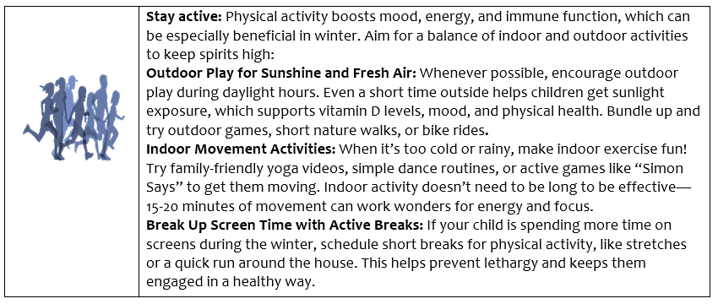

Visit the country park and gardens Twelve Days of Christmas Trail open every day from until 24th December.
Parking is £5 for the day or £1 for 2 hours.
Bus number 94/94a from Barnsley interchange.


Visit the Heritage Centres Christmas Trail.
Open every day until 2nd January 2025 10am – 4pm.
Free parking.
Bus number 66 from Barnsley interchange.

- Festive events around Barnsley

Visit the Enchanted Tree Trail this winter at Wentworth Castle Gardens.
Open every day in December and January 10am-4pm.
Parking is free. Admission is charged at £15 for a family ticket.
Bus numbers 24 & 34 from Barnsley interchange.

Page 2

For financial support, Barnsley Council’s Welfare Support offers advice on benefits, energy support, and emergency funds for families in need. Visit their website https://www.barnsley.gov.uk/services/benefits/more-money-in-your-pocket-cost-of-living-support/ or contact 01226 773555.
Many people are having difficulties due to the current cost of living. You might not realise you're entitled to some help. You can find out about the range of local help that's available, as well as national support, on this website.
In response to the cost of living, the government has also launched a campaign to let everyone know what national support is available. This is called Help for Households.

- Help with the cost of living
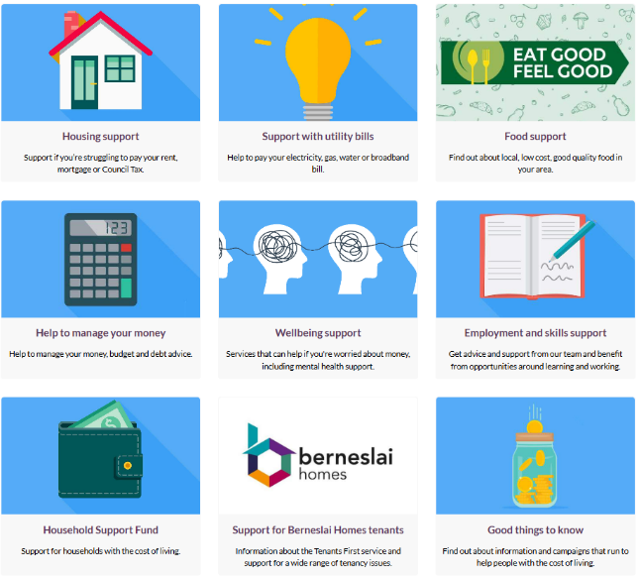
- Supporting your child’s mental health and wellbeing

Page 3

Page 4

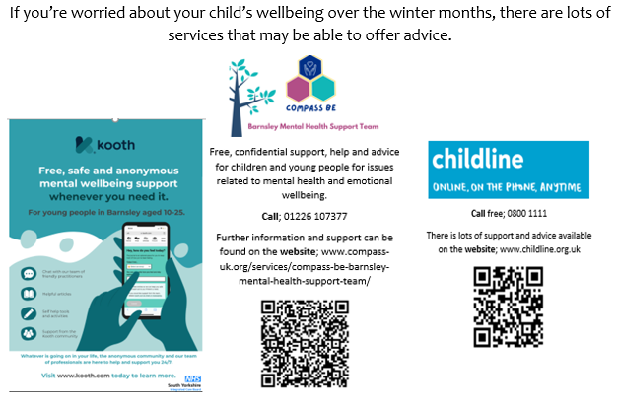
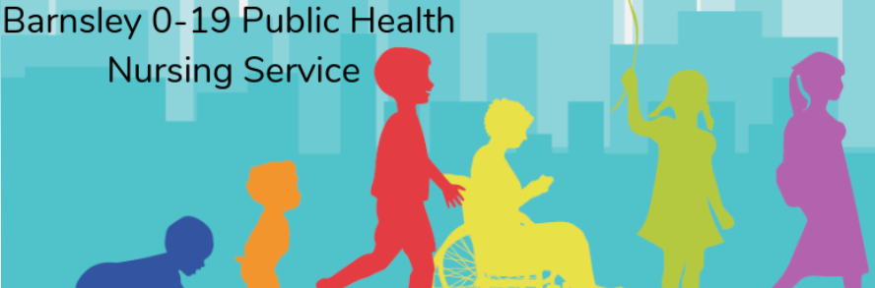
You can also contact Barnsley’s 0-19 Public Health Nursing Team on 01226 774411 or follow them on Facebook.

Page 3

- Supporting your own mental health and wellbeing
If you’re worried about your own mental health, these services may be able to offer advice and support.



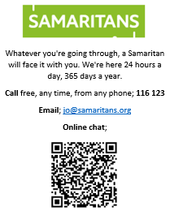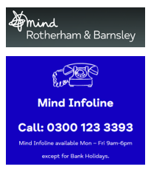

Page 4

- How do school support my child’s mental health and wellbeing?
Our recent wellbeing survey highlighted that some parents are not aware of the things we do in school to support children’s wellbeing and how we help them to learn to look after their own wellbeing. So, we thought it would be useful to share some of the things we do!
- We start by creating a positive and safe environment in our school, ensuring that clear and predictable routines are in place for children to follow and that all adults work together to prioritise the wellbeing of every child.
2. In school, we support children to acquire the knowledge, understanding and skills they need to manage their lives, now and in the future. Our Personal Development education develops the qualities and attributes children need to thrive as individuals, family members and members of society. Personal Development is woven into all parts of our curriculum. It is also responsive to the needs of each cohort and the wider school and community. We deliver discrete Personal Development lessons for all pupils which focus on objectives linked to RSE, PSHCE, British Values and SMSC. This term we have focused on the theme ‘living in the wider world’.
3. Incredible Me! is a wellbeing system that has been especially designed by schools in the ECM Academy Trust to support our children in developing resilience, independence and self-esteem. It also supports them to recognise and manage their own feelings. Incredible Me! identifies age-appropriate skills or ‘superpowers’ that we would like children to develop during their time in school. It provides school staff with activity ideas for whole class, group and individual support to ensure children develop the required skills.
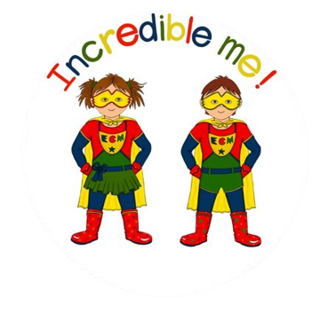

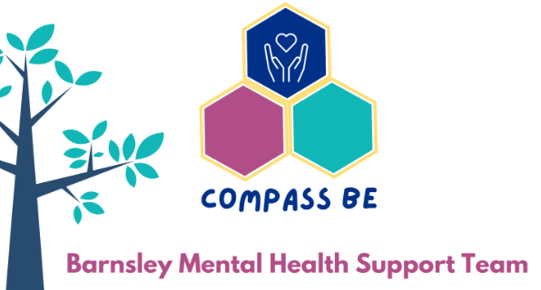
3. In school, we have close links with Compass Be, who can offer support in school through workshops, assemblies, small group support and individual intervention. Our Compass Be link worker meets with us regularly and helps us to identify things that we can do to ensure we are offering the most effective support for children’s wellbeing.

Page 5

Page 8


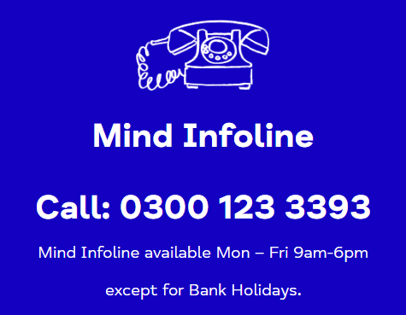

Page 9

